Issue Report
Product: | LightHouse | Report Date: | 18/05/2021
Issue Summary: | Search by user/label with characters, symbols and sign names  result in showing full list of users instead of none
Version/ Found on (day/month/year): | 18/05/2021
Hardware/Software configuration: | Ubuntu 20.04 LTS, Chrome
Importance/ Severity:

Reported by  (team name): | Morning Coffee
Issue type (defect/enhancement): | Defect: no empty list is shown when searching with special characters, symbols or sign names
Steps: | 1.Go to https://lighthouse-demo.evozon.com/.  2. Input a special character, symbol or sign name, like for example è , inside the search by user / label field
Expected output: | Empty list
Actual output: | List of all users and labels
Screenshots: | 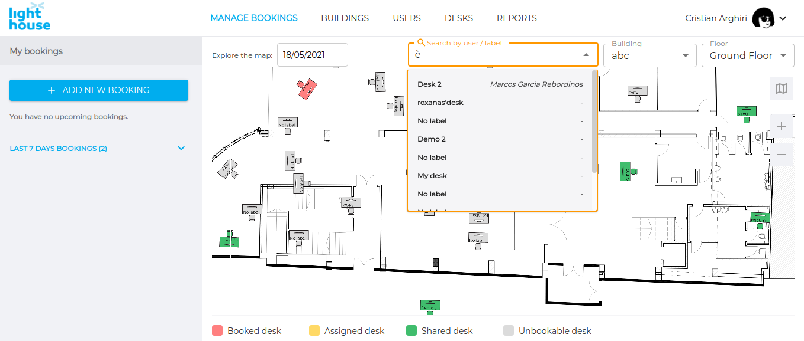
Other details/remarks:

